

The Lighthouse
Zion & Trinity Lutheran Churches
950 Huron
St. Ignace, MI 49781

Address Service Requested

Nonprofit Org.
U.S. Postage
PAID
St. Ignace, MI 49781
Permit No. 55

,

The Lighthouse
Zion & Trinity Lutheran Churches
950 Huron
St. Ignace, MI 49781

Address Service Requested

Nonprofit Org.
U.S. Postage
PAID
St. Ignace, MI 49781
Permit No. 55

,


THE LIGHTHOUSE

Newsletter for December 2018

The sun will no more be your light by day, nor will the brightness of the moon shine on you, for the LORD will be your everlasting light, and your God will be your glory.
Isaiah 60:19

Message from our pastor

Dear Brothers and Sisters in Christ,

I love the season of Advent. The color of the season is blue and not the green we have been accustomed to the last few months. Now don’t get me wrong, I like the green, but it’s time for change. It’s also a season of Reflection and Hope.

Advent seems to have become the lost and forgotten church season. It has gotten lost in the rush of the good Christmas deals and all the rest of the trappings of the commercialization of Christmas. Yet it is an important time in the life of the Christian church. Especially in the times we are living in; where fear, polarization, and gloom and doom seem to have a grip on many aspects of our lives. It’s not hard to see, we live in a world longing for hope. Wars are raging, and people are fleeing their countries because of it. It’s also winter, and though beautiful in many ways, it also poses hardships. There are times when we seem to be stuck in one place due to cold and snow. It’s also a time when the bills can stack up with the costs of heating our homes. When we look at all that, we long for a little hope and where does that come from? Our Lord and Savior Jesus Christ!

During Advent I usually reflect on all the events that happened in my life in the last year, some good and some not so good. Then when I see the mangers and the Christmas trees popping up all over, as the Christmas season begins, I begin to look at where Christ is in all of these events.

I have always given thanks for the season of Advent and Christmas because they remind me to reflect on where Christ is in my life and in a world longing for hope. That hope all began with a baby, our Emmanuel (which means God among us in flesh) who would preach and teach, care for those whom society neglected, and finally go to the cross taking on all our pain and sin, to die for us and then rise again giving us eternal life! The Light that the darkness can not overcome!

Christ, who is our hope, is with us now and will come again! Thanks be to God!!

May your Christmas be filled with happiness and Joy!

Yours in Christ,
Pastor David

Noisy Offering

The December Noisy Offering will go to The Food Pantry. Need is always greater at this time of the year. We will

also be collecting non-perishable food during the month of December.

Newsletter

The December newsletter was not adopted. ☹

Advent


Advent began November 29th! Advent is a time to focus inward and prepare our hearts and lives for Christ. This is the countdown and earnest waiting for the Messiah. Please take some time during this season to:

- Worship weekly
- Pray daily
- Read your Bible daily
- Practice generosity

Trinity Christmas Dinner

Trinity Lutheran Church in Brevort is hosting its Annual Community Dinner on Saturday, December 1st. Appetizers will start at 5 pm, dinner being serve at 6 pm. All Brevort and surrounding areas are welcome.

Adult Bible Study

Trinity Bible Study will be Tuesdays at 6 pm.

Confirmation

Confirmation will be on December 9th starting at 5:00 pm

Visions of Christmas’s Past

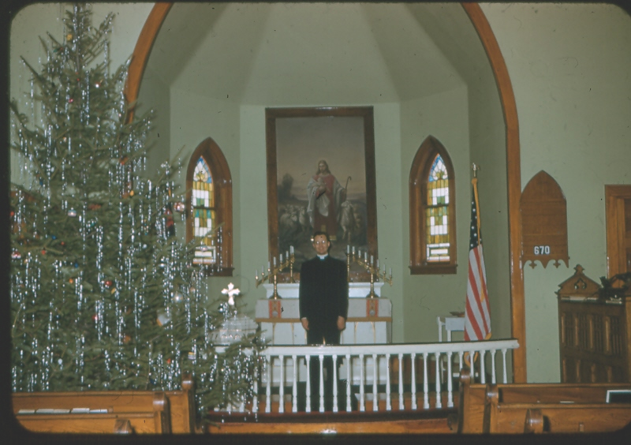

Top: Trinity Christmas 1955 Bottom: Zion Christmas 1955
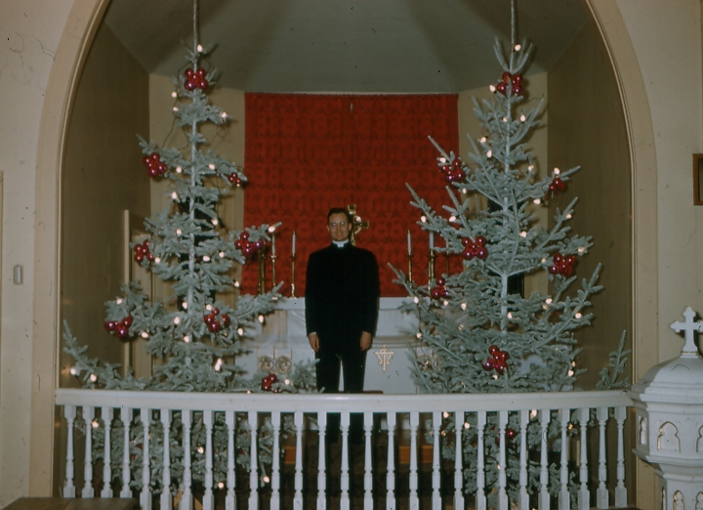

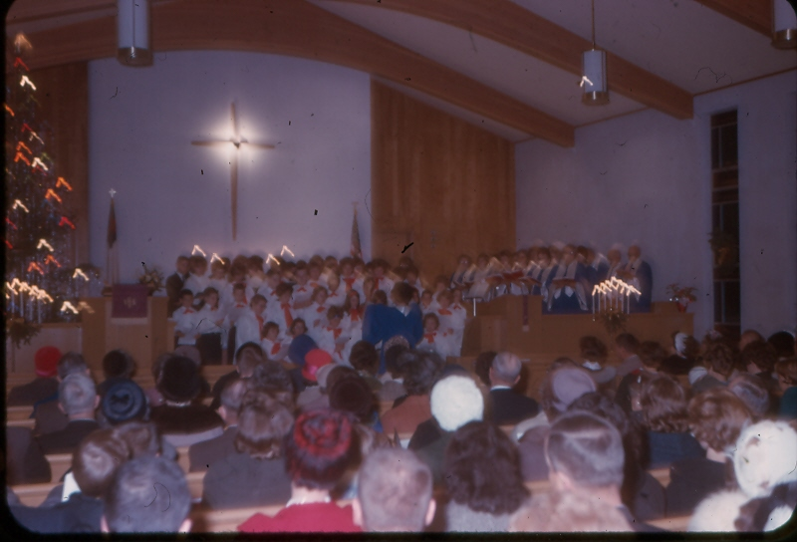

Zion Christmas Concert 1963
For clearer photos, see the December Newsletter at http://zionstignace.com/newsletter.html

Poinsettias

Anyone wishing to order poinsettias for the
Christmas Eve service, can contact Betsy Turf at
906-643-1512 from December 9th until the 18th.
Cost is $12 for red, burgundy, white or jingle bells
(red & white). You can choose silver or gold foil.

Christmas Eve Services

Join us as we celebrate the birth of our Savior on Christmas Eve. Trinity will meet at 5 p.m. and Zion at 8:00 p.m.

Cross Wreaths

The cross wreaths hanging in our sanctuary for the Christmas service at Zion were donated:

In memory of Jerry Fenlon from Susan, Michael, Mandy and families.

In memory of Linda Wilkins from her husband Mike Wilkins.

In remembrance of Don & Gracie Graham from the Rita & David LaVake

In memory of Nancy Hardy from Ken Hardy and family.

In memory of Gary Olsen & Joy Marolf from Marlene Olsen, John and Connie and family.

In memory of William & Helen Morand and Martin & Dorothy Van Driel from Lynn Evans.

In memory of Bob Therrian and in honor of the Therrian family.

In honor of Eunice Therrian, Mother, Grandmother & Great Grandmother from the Therrian family.

In honor of Bill & Sandy Tielbar and Wally & Jane Puccio from Pastor Dave and family.

Contact Information

Pastor David Tielbar may be reached at 906-984-2051 or at david.tielbar6@gmail.com. In an emergency, you can reach the Pastor’s cell phone at (563) 880-4512

Church telephone: 906-643-7870 - Answering machine
The secretary will usually be in the office on Tuesday and Thursday mornings from 9 – 12

The website is at http://zionstignace.com/home.html
- Find us on facebook at www.facebook.com/zionstignace

Email: ziontrinity950@gmail.com

Zion Evangelical Lutheran Church and Trinity Lutheran Church are congregations of the Northern Great Lakes Synod and the Evangelical Lutheran Church in America.

Trinity’s Sunday Service is at 9 a.m.
Zion’s Sunday Service is at 11 a.m.

Prayer List

If you would like someone added to the prayer list, please fill out a yellow card or call the church)

Mary Belonga, Dave & Lois Movalson, Barb Lehto, Bev Kammers, Eunice Therrian, Craig Therrian, Shirley Winberg, Richard Galor, Judy Ryerse, Cindy Hendricks, Carol Litzner, Holly Lester, Sandy Huskey, Jim & Jerri Rose, Bill & Sandy Tielbar, Walter & Jane Puccio, Carol & John Watson, Mike Wilkins, Larry Hopper, David Lloyd, Donna Harju, Tom Beaudoin, Terri Hill, Gayle Kaminsky Pande, Ann Blaine, Mary Ellen Reavie, Sylvia Richards, Krista MacArthur, Bill & Ann Anderson, Pastor Joe, Sam, Dorothy Pechta, Chase Hancock, Jerome Robbins, Jack & Alfie Dyer, veterans with PTSD, Ed Heenan, John Latta, Lloyd & Marion Steiner, Levi Thompson, Zachary Baron, Charlie, Odel, Nicholas, Tim Brown, Brenda Lightfoot, Pastor Shane Anderson, Kay Bahlman and the family and friends of Merlin Doran.

Christmas Music

Come enjoy the music of the Annual Christmas Musicale at the
United Methodist Church on December 2nd at 6:30 pm. and enjoy the Straits Area Cantata on December 9th at 2 pm at
St. Anthony’s Catholic Church in Mackinaw City.


Birthdays in December

December 2 Andrea Insley
4 Bonnie Bergeron
- Joyce Gustafson
- Josh LaJoice
- Sue St. Onge
12 Trudy Olsen
14 Bill Harju
15 Tonya Winberg
20 Robby Olsen
22 Sally Idalski
23 Chase DeKeyser
24 Carol Elmblad
24 Toby Ferguson
25 Robert Marshall
26 Lorraine Graham
29 Barb Wilkins
Anniversaries in December

December 1 Dave & Lois Movalson
December 10 Jim & Jerri Rose
December 28 Tim & Sally Idalski

Baptismal Anniversaries

December 2 Madison Olsen
3 Kelly LaJoice
7 Zoey Stenson

9 Brad Therrian
15 Rita LaVake
15 Connie Olsen
19 Joshua Feleppa
20 Lana Lennington
20 Sue St. Onge
24 Bernard Crouch
24 Katti Gamble
24 Alicia Garen
24 Cole Garen
25 Jordan Caldwell
27 Dawn Akers
27 Lucas Hammond
27 Brent Ruff
27 Jayce Ruff
27 Drew Stockero
28 Kristine Vallier
29 Barb Wilkins
30 Max Coburn

Evergreen Living Center

Barb Lehto

Castle Rock Retirement Center

Judy Ryerse

Servants for Zion

Ushers & Greeters

Dec 2 Mark & Carol Elmblad
Dec 9 Susan Fenlon & Lorraine Graham
Dec 16 Martha Sjogren & Lorraine Graham
Dec 23 Andrea Insley & Tina Schlehuber
Dec 24 Lana Lennington Family
Dec 30 Volunteers

Lectors

Dec 2 Richard Galor
Dec 9 Cathie Tielbar
Dec 16 Betsy Turf
Dec 23 Lorraine Graham
Dec 24 Dawn Akers
Dec 30 Sandy Feleppa

Communion Assistants

Dec 2 Mary Christiansen
Dec 9 Carol Elmblad
Dec 16 Dena Barker
Dec 23 Tammy Shepard
Dec 24 Emma Feleppa

Acolytes

Dec 2 Josh Feleppa
Dec 9 Brendan Insley
Dec 16 Gunnar Olsen
Dec 23 Josh Feleppa
Dec 24 Brendan Insley

Altar: Betsy Turf
Money Counters: Steve & Mary Christiansen

The Usher duties are:
- Arrive 30 minutes before church
- Pass out bulletins and welcome guests
- Help with the offering and communion
- Record attendance

Zion Funeral Committee Oct - Dec

Team Leader: Lorraine Graham (643-8419)
Co-leader: Betsy Turf (643-1512)

Trinity Worship Families

Dec 2 Chalmers Family
Dec 9 Kennedy Family
Dec 16 Rose Family
Dec 23 Movalson Family
Dec 24 Baron Family
Dec 30 Chalmers Family

Council Meetings

Trinity Council –December 18, 2018 – 6 pm
Zion Council – December 19, 2018 – 6:30 pm

Zion’s Council Members
President: Steve Christiansen 298-1051
Vice-President: Carol Elmblad 630-4380
Co-Treasurers: Dawn Akers 643-7552
Co-Treasurers: Lana Lennington 643-6576
Mary Christiansen 235-6123
Robert Marshall 643-8936
Secretary Dena Barker 430-1460
Emma Feleppa 430-8011
Tammy Shepard 906-984-2064

Trinity’s Council Members
President: Jerri Rose 292-5570
Vice-President Sharon Chalmers 292-5440
Secretary: Tracy Movalson 292-5581
Treasurer: Pega Kennedy 292-5633
Co-Treasurer: Jim Rose 292-5570
Financial Secretary: Tom Gustafson 292-5460
WELCA: Pega Kennedy 292-5633
John Kennedy 292-5633
Lois Movalson 292-5581

Trinity Lutheran Church Minutes

November 20, 2018

Present: Pastor Dave, Jerri & Jim Rose, Pega & John Kennedy, Tracy Movalson, and Tom Gustafson.

Guests: Joe Chalmers and Joyce Gustafson

Meeting began at 6:08pm

Opening: Pastor read Hebrews 10, vs 11-25 God’s Gift of Grace

Pastors Report: Thank you for the time off for celebrating the 125th anniversary of church where he did internship. Going to Iowa for Thanksgiving and Jerri will handle both church services. Going to synod retreat in Escanaba February 10-12, 2019

Secretary’s Report was read. Motioned by Tom and supported by Sharon and approved.

Treasurer’s Report was read. Motioned by Sharon and supported by Tom and approved.

Financial Secretary’s Report was read. Motioned by Jerri and supported by Sharon and approved.

Old Business:

Getting great response and donations for Altar painting fund project.

Delivered the toys to Toys for Tots today.

New Business:

Community dinner is Saturday, December 1, 2018. Pega will handle the meal and parishioners will bring hors d’oeuvre and desserts.

Tracy suggested that we get basement pictures restored with UV protected glass.

Meeting adjourned at 6:30pm

Respectfully Submitted,
Tracy Movalson
Secretary

~~~

Jesus is the Lord of Life. Is he the Lord of yours?



Wishing You a Blessed Christmas!

